**Introduction**

The Book of Ecclesiastes, attributed to King Solomon, presents a profound exploration of the meaning and purpose of life. Through philosophical reflection and observations on the fleeting nature of human existence, Ecclesiastes offers insights into the pursuit of wisdom, the vanity of earthly pursuits, and the ultimate satisfaction found in fearing God and keeping His commandments.

**Structure and Argument**

(1) A Basic Outline of Ecclesiastes (cf. Dillard, An Introduction to the O.T., p.251)

1:1-11 Prologue

1:12-12:8 Monologue of Qohelet

12:8-14 Epilogue

(2) A More Detailed Outline of Ecclesiastes (cf. Golding, D.T.S. Notes, Ecclesiastes pp.6-7)

“Though many structures have been proposed for Ecclesiastes, the most helpful and the one that has stood the test of time is that of A. Wright. He saw a basic twofold division in the book based on the repetitions of key terms and phrases. The key phrase of the first half (1:12–6:9) is “vanity and striving after wind.” Dominating the thought of the second half (6:10–11:6) are the phrases “cannot find” and “does not know.” The basic structure of the book is essentially symmetrical as follows.

1:1 Superscript

1:2 Motto: “Vanity of vanities, everything is vanity!”

1:3-11 Prologue/Poem

1:12–6:9 Man’s activity is “vanity and striving after wind”

6:10–11:6 Man’s inability to discover God’s plan or know the future

11:7–12:7 Epilogue/Poem

12:8 Motto: “Vanity of vanities, everything is vanity!”

*12:9-14 Postscript”*

Golding’s chart of the book follows Wright’s outline.

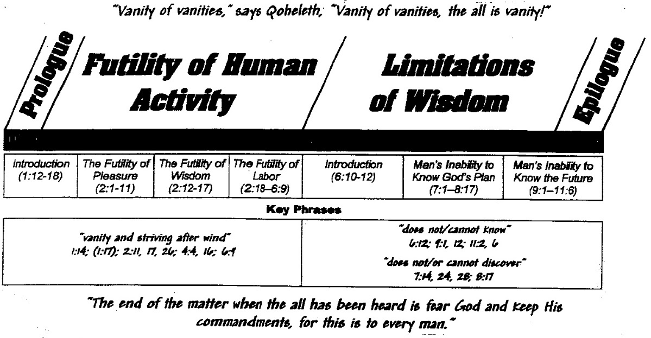

**Significant Themes**

(1) The Meaninglessness of Life ‘Under the Sun’

“Hevel, hevel, everything is hevel.” This repeated refrain from the author encapsulates his view that ‘under the sun’ life is futile, frustrating and unfair.

|  |  |
| --- | --- |
| Futility | |
| Pursuit | **Result** |
| Pleasure (2:1, 10) | ‘meaningless’ (2:1) |
| Laughter (2:2) | “Yet when I surveyed all that my hands had done and what I had toiled to achieve, everything was meaningless, a chasing after the wind; nothing was gained under the sun.” (2:11 see also 2:19-21) |
| Alcohol (2:3) |
| Human endeavours (2:4f) |
| Wealth (2:8a) |
| Sex (2:8b) |
| Status (2:9) |

|  |
| --- |
| Frustration |
| God ‘has set eternity into the hearts of men; yet they cannot fathom what God has done” (3:11) |
| A man toiling alone with no son or brother, never having enough wealth – miserable! (4:8) |
| A man cannot discover anything about his future (7:14) |
| No one can comprehend what goes on under the sun…man cannot discover its meaning…he cannot comprehend it (8:17) |

|  |
| --- |
| Unfairness |
| In the place of justice wickedness was there (3:16) |
| The oppressed have tears and the oppressors have power (4:1) |
| The poor are oppressed and the powerful corrupt (5:8) |
| A righteous man perishes in his righteousness, a wicked man lives long in his wickedness (7:15) |
| Righteous men get what the wicked deserve, and the wicked get what the righteous deserve (8:14) |
| Pending death (3:2, 9:2-3, 12:7) |

(2) The Fear of God

Here is the solution the author repeatedly gives to the futility, frustration and unfairness of life under the sun. The fear of God will be attained as readers:

* Pursue wisdom (7:12; 8:1; 9:18; 12:9-11)
* Enjoy God’s gifts (2:24; 3:12-13; 3:22; 5:18; 8:15; 9:7; 11:9)
* Rest in God’s judgment (3:17; 11:9; 12:13-14)

**Points of Interest**

(1) Authorship and Purpose

Dillard believes Ecclesiastes encompasses the works of two authors. Most of the book is written by Qohelet [‘Teacher’] (1:12-12:8), the doubter and sceptic. Most of what he says is wrong. The other author is orthodox and the source of the positive teaching in the book (1:1 -11 & 12:8-14). This writer frames the thought of Qohelet and critiques him vigorously in chapter 12. Thus “Qohelet’s speech (1:12-12:7) is a foil, a teaching device, used by the second wise man to instruct his son (vs. 12) concerning the dangers of speculative, doubting wisdom in Israel.” (Dillard, 253-254) See the appendix for a fuller explanation by Dillard.

Chisholm also leaves room for two authors, the Teacher and an editor who frames the teacher’s thoughts. However, unlike Dillard, Chisholm believes the editor respects the teacher's wisdom and takes his advice to its logical conclusion. “Life, as far as one can determine by observation, is rendered meaningless by death. Therefore, one’s only hope for meaning lies in God.” See Appendix 1 for a fuller explanation by Chisholm.

Dorsey favours one author who deliberately moves his readers from the negative to the positive to address the issue of life’s meaning. The negative is designed to demolish the misguided hope that this life, apart from God, has any meaning. The positive is intended to reveal that God has the answers to life’s meaning, so the reader should live wisely by trusting in God (pp. 197-198).

(2) The references to ‘soul sleep’ (cf. 3:19-21: 6:6,12: 9:5-6*)*

These passages seem to indicate that the author of Ecclesiastes believed that the same fate awaited men at death as awaited beasts. All man can look forward to is returning to the dust, where he knows nothing and has no reward. Thus, man is like a beast, and life is meaningless. Seventh-Day Adventists among others point to these passages to support their doctrine of soul sleep - the soul sleeps after death. Most of these groups believe that the righteous will be awakened from this sleep in the future, but the unrighteous will go on sleeping.

The NIV Study Bible’s comments on some of these verses are helpful:

3:18 “like the animals. Man ‘under the sun’ (man on his own) is as mortal as any animal; but, unlike them, he must be made to see this condition and, through his dim awareness of eternity (v.11), be distressed” (pp.994-995)

3:20 “to the same place. Not heaven and hell but man’s observable destination, which is a return to dust, just like the animals. Death is the great leveller of all things.” (995)

6:6 “to the same place. Still talking in terms of what we can observe (that all men die), not of what lies beyond death (see v.12; 3:21)” (997)

9:5“no further reward. The dead have lost all opportunity in this life for enjoyment and reward from labor (see v.6)” (999).

(3) The Apparent Contradictions in the Book (cf. Golding, Ecclesiastes pp.4-5)

“A variety of approaches have attempted to deal with the contradictions found in the book (e.g., Qoheleth’s positive and negative view of wisdom). One approach is to deny that there are any genuine contradictions. Any contradictions are only apparent and can be harmonized by a proper reading of the text. A second approach is to acknowledge the presence of genuine contradictions and say that the book contains “original” Qoheleth sayings plus modifications by other “glossators.” A third approach is to “hear different voices” in the book. In other words, Ecclesiastes is the on-going dialogue between Qoheleth and one less wise than he, such as a student, inquirer, or skeptic. A fourth approach hears Qoheleth quoting traditional sayings and either refuting or modifying them [cf. Whybray]. A fifth approach views Ecclesiastes as containing *zwar - aber* sayings (“yes . . . but . . .”). This view seeks a synthesis of thesis and antithesis [cf. Hertzberg]. A sixth approach sees one speaker presenting different perspectives. Qoheleth is debating between early traditional wisdom (e.g., Proverbs) and his own observations from life [cf. Murphy]. A seventh approach highlights “polar opposites,” that is the presence of “opposites and tensions.” One pole is traditional wisdom, the other pole a newer outlook. In this case it is the reader, and not Qoheleth, who does the synthesizing [cf. Loader]. An eighth approach is that of Fox, who argues that no synthesis is possible [cf. Fox]. Since Qoheleth did not try to reconcile the contradictions, neither should the reader. A ninth approach is a hybrid. It suggests that Qoheleth dialogues with himself and also acknowledges the contradictions of life [cf. Seow]. Finally, a tenth approach sees the contradictions of Ecclesiastes as the psychological tensions of a mentally disturbed individual [cf. Galling].”